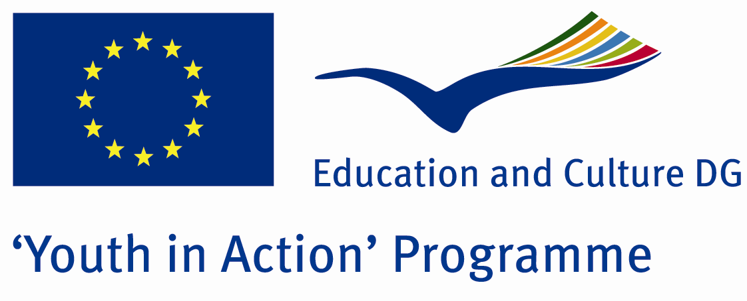

The Fate of Unlucky Children



ACTION 4.3 – Training And Networking

07-13th July 2011

Balıkesir/TURKEY

Please contact directly to;

adventurerpeacepigeons@gmail.com

Project Summary;
This Project is about youngsters who are arrested because of stealing something, drugs, disturbing people and like that… You know youngsters are our future. One day they will dominate this world… And thousands people are living in the street. There is no education, no food, no home, no family… We want to attract attention for these people. Everything doesn’t mean fun or holiday or car or Money… Sometimes, you must save your environment, your people or world… For example Edison discovered electric and now you are using it… Or computer or other things… I mean that if you live in this world, you must add something. Start with youngsters who are living in street. Let’s do something for them… Maybe a small present, maybe a smiling face… Give your family love for them… If you want to join us, please send your application form…

Project Title; The Fate of Unlucky Children

Date and Venue; 07-13th July 2011, Balıkesir/TURKEY

Target Group; Non profit/non governmental organization, Public body, Body active at European level in the field of youth (ENGO), Informal group of young people, e.t.c…

Participants; 5 people from each country (18 - 25). Totally 8 countries.

Conditions; Accommodation, board and programme costs will be financed through European Commission Youth in Action Programme (Action 4.3). Travel costs will be reimbursed in 70% (APEX Tarrifs). Organizations from all 27 EU member countries plus Liechtenstein , Norway and Iceland are eligible to take part.

Working language: English

Organizer; Discovery And Adventure Group

How to apply: If you are interested, please send your Part III forms to
0090 216 483 21 67 by FAX please. (Fulfilled Part III which you can find in the attachment, of course signed and stamped) ..

Note: jpeg is not allowed..please send by fax…

Next step 2;
Original send via regular post to this address please:

Ertan DERİN
Öner İnşaat
Abdulhalik Renda Cd.
Parlar Sk. No:4 Pendik/İSTANBUL

If you have any questions you may contact with: adventurerpeacepigeons@gmail.com

Deadline for application; until 20th January 2011.
For Further information:
Contact Person
Ertan DERİN
Öner İnşaat
Abdulhalik Renda Cd.
Parlar Sk. No:4 Pendik/İSTANBUL
e-mail : adventurerpeacepigeons@gmail.com
Mobile : 0090 542 393 93 90
Fax : 0090 216 483 21 67

